**PROJECT PHASE-III SYNOPSIS (ECE)**

**ON**

**MULTI-PURPOSE ARDUINO BOT**

*A report submitted in partial fulfilment of the requirement for the award of*

*The degree of*

**BACHELOR OF TECHNOLOGY**

**IN**

**ELECTRONICS AND COMMUNICATION ENGINEERING**

**Submitted by:**

**Ashutosh Singh (180103017)**

**Mentored by:**

**Dhruva Chaudhary**

**ELECTRONICS AND COMMUNICATION ENGINEERING DEPARTMENT**

**DIT UNIVERSITY, DEHRADUN**

(State Private University through State Legislature Act No. 10 of 2013 of Uttarakhand and approved by UGC)

**Mussoorie Diversion Road, Dehradun, Uttarakhand - 248009, India**

**ACKNOWLEDGEMENT**

I would like to take this opportunity to pay my sincere thanks to

**Dr. Sonika Singh (Head, Department of EECE)** who allowed me to carry out this project and provided me with her valuable guidance and suggestion.

I would like to give my sincere thanks and regards **Mr. Dhruva Chaudhary**, who have always provided me the moral support for completing this work.

I would like to dedicate this work to my parents and my all friends who have always supported me in motivational way towards understanding the life and the importance of work.

Last but not least, I would like to thank friends whose toilsome efforts, constant inspiration and affection helped me to complete this work.

**Ashutosh Singh**



**CANDIDATE DECLARATION**

I hereby certify that the Online report which is being presented here entitled **“Multi-Purpose Arduino Bot”** in the partial fulfillment of the requirements for the award of the degree of Bachelor of Technology and submitted in the Department of Electrical and Electronics & Communication, DIT University, Dehradun, Uttarakhand is an authentic evidence of my own work learning under the supervision of **Mr.** Dhruva Chaudhary, Assistant Professor, Department of Electrical and Electronics & Communication Engineering, DIT University, Dehradun.

**Ashutosh Singh**

This is to certify that the above statement made by the candidate is correct to the best of our knowledge.

**Date. 4th December, 2020**

**Mr.** Dhruva Chaudhary

**TABLE OF CONTENTS**

* Abstract
* Special Features of The Bot
* Hardware Components
* Working Methodology
* Working on IDE
* Applications
* Result
* Certificate of Coding Course
* REFERENCES

**ABSTRACT**

Line Following is one of the most important aspects of robotics. A Line Following Robot is an autonomous robot which is able to follow either a black or white line that is drawn on the surface consisting of a contrasting colour.

It is designed to move automatically and follow the made plot line. The robot uses several sensors to identify the line thus assisting the robot to stay on the track. The array of four sensor makes its movement precise and flexible.

The robot is driven by DC gear motors to control the movement of the wheels. The Arduino Uno interface is used to perform and implement algorithms to control the speed of the motors, steering the robot to travel along the line smoothly.

This project aims to implement the algorithm and control the movement of the robot by proper tuning of the control parameters and thus achieve better performance.

However my aim is to make this bot more dynamic and adjustable as I learn more things, it will not remain just a line following robot but will work on user commands as well, This bot will also have self decision making capabilities and will take appropriate action

**SPECIAL FEATURES OF THE BOT**

1. **Line Follower Bot:** I Will Be Learning the Logics and Implementation of Line Follower Robot.
2. **Upgrade to Obstacle Avoiding:**  New Functions Will Be Added to Make It Obstacle Avoiding Thus Decision-Making Capabilities Will Be Provided.
3. **Object Tracking:** Will Make It More Dynamic with Added Functionality of Object Tracking.
4. **Light Follower: Next Step Will Be to Make the Bot Track the Light.**
5. **Voice Control:** Next Step Will Be to Make the Bot Understand User Commands.
6. **Gesture and App Control:** The Final Milestone Will Be to Make the Bot Controlled By Gestures And App.

**SYSTEM REQUIREMENTS**

* **Software Requirements:**
* **Windows 7 or above**
* **Arduino IDLE**
* **Hardware Components:**
* **Processor – Core i3 or above**
* **Arduino UNO**
* **Motor Controller**
* **Robot Chassis**
* **Motor Driver**
* **Motors**
* **HC05 Bluetooth Module**

**ARDUINO: -**

The Arduino Uno Is An Open-source Microcontroller Board Based On The Microchip Atmega328p Microcontroller And Developed By Arduino. Cc.

The Board Is Equipped With Sets Of Digital And Analog Input/output (i/o) Pins That May Be Interfaced To Various Expansion Boards (shields) And Other Circuits.

The Board Has 14 Digital I/o Pins (six Capable Of Pwm Output), 6 Analog I/o Pins, And Is Programmable With The Arduino Ide (integrated Development Environment), Via A Type B Usb Cable.

It Can Be Powered By The Usb Cable Or By An External 9-volt Battery, Though It Accepts Voltages Between 7 And 20 Volts

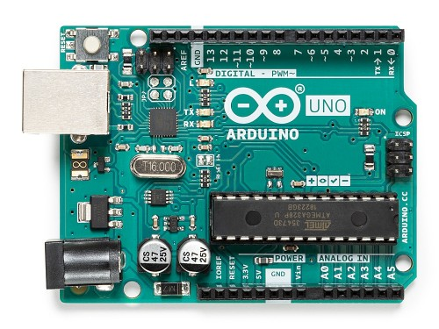

**Motor Controller: -**

A Motor Controller Is A Device or Group of Devices That Can Coordinate in A Predetermined Manner the Performance of An Electric Motor.

A Motor Controller Might Include A Manual or Automatic Means for Starting and Stopping the Motor, Selecting Forward or Reverse Rotation, Selecting and Regulating the Speed, Regulating Or Limiting The Torque, And Protecting Against Overloads And Electrical Faults.

There Are Many Types of Motor Controller:

1-Motor Starters

2-Reduced Voltage Starter

3-Adjustable Speed Driver

4-Intelligent Controller

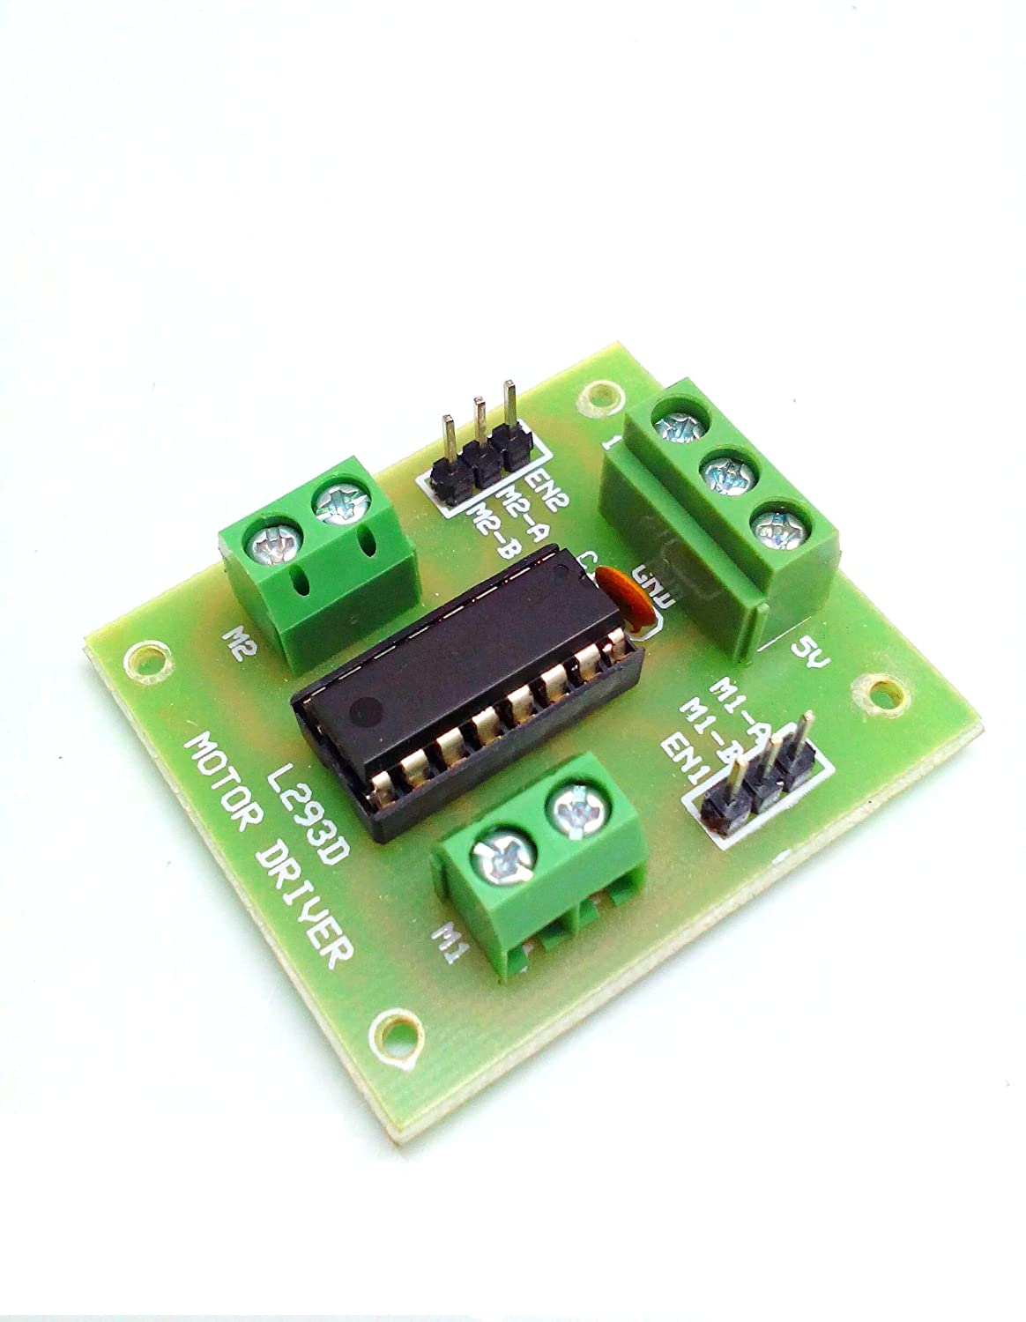

**Robot Chassis**

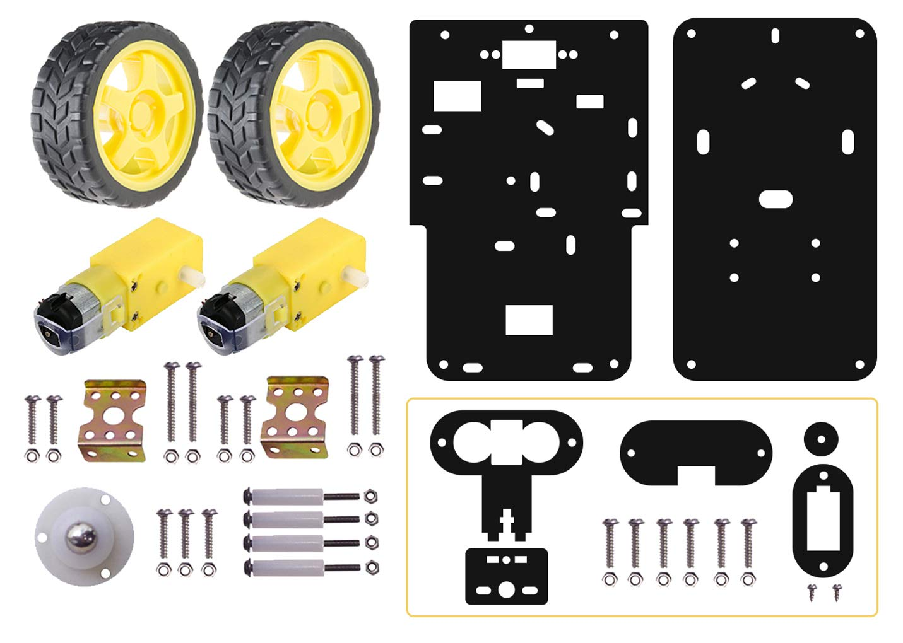

It contains outer body and required parts for the robot i.e Tyres, Motors, Screws and Bolts

**HC-05 Bluetooth Module**

The **HC-05** has two operating modes, one is the Data mode in which it can send and receive data from other Bluetooth devices and the other is the AT Command mode where the default device settings can be changed. We can operate the device in either of these two modes by using the key pin as explained in the pin description.

It is very easy to pair the HC-05 module with microcontrollers because it operates using the Serial Port Protocol (SPP). Simply power the module with +5V and connect the Rx pin of the module to the Tx of MCU and Tx pin of module to Rx of MCU as shown in the figure below

During power up the key pin can be grounded to enter into Command mode, if left free it will by default enter into the data mode. As soon as the module is powered you should be able to discover the Bluetooth device as “HC-05” then connect with it using the default password 1234 and start communicating with it. The name password and other default parameters can be changed by entering into the

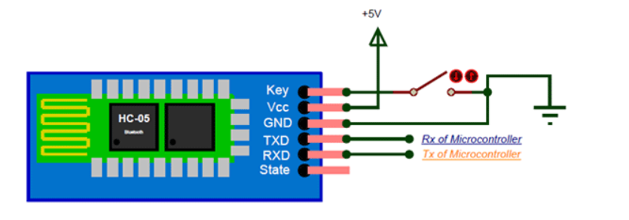

**METHODOLOGY**

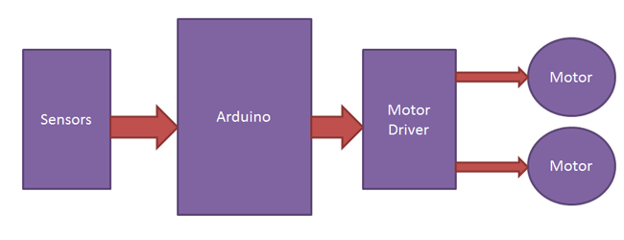

**Arduino Code On Ide For**

**Button Controlled Bot**

void setup() {

pinMode(3,OUTPUT);

pinMode(4,OUTPUT);

pinMode(5,OUTPUT);

pinMode(6,OUTPUT);

Serial.begin(9600);

}

void loop()

{

if(Serial.available())

{

int z = Serial.read();

if(z==1)

{

digitalWrite(3,HIGH);

digitalWrite(4,LOW);

digitalWrite(5,HIGH);

digitalWrite(6,LOW);

}

if(z==2)

{

digitalWrite(3,LOW);

digitalWrite(4,HIGH);

digitalWrite(5,LOW);

digitalWrite(6,HIGH);

}

if(z==3)

{

digitalWrite(3,HIGH);

digitalWrite(4,HIGH);

digitalWrite(5,HIGH);

digitalWrite(6,LOW);

}

if(z==4)

{

digitalWrite(3,HIGH);

digitalWrite(4,LOW);

digitalWrite(5,HIGH);

digitalWrite(6,HIGH);

}

if(z==5)

{

digitalWrite(3,HIGH);

digitalWrite(4,HIGH);

digitalWrite(5,HIGH);

digitalWrite(6,HIGH);

}

}

}

**Arduino Code On Ide For**

**Voice Controlled Bot**

void setup() {

pinMode(3,OUTPUT);

pinMode(4,OUTPUT);

pinMode(5,OUTPUT);

pinMode(6,OUTPUT);

Serial.begin(9600);

}

void loop()

{

if(Serial.available())

{

int z = Serial.read();

if(z==1)

{

digitalWrite(3,HIGH);

digitalWrite(4,LOW);

digitalWrite(5,HIGH);

digitalWrite(6,LOW);

}

if(z==2)

{

digitalWrite(3,LOW);

digitalWrite(4,HIGH);

digitalWrite(5,LOW);

digitalWrite(6,HIGH);

}

if(z==3)

{

digitalWrite(3,HIGH);

digitalWrite(4,HIGH);

digitalWrite(5,HIGH);

digitalWrite(6,LOW);

}

if(z==4)

{

digitalWrite(3,HIGH);

digitalWrite(4,LOW);

digitalWrite(5,HIGH);

digitalWrite(6,HIGH);

}

if(z==5)

{

digitalWrite(3,HIGH);

digitalWrite(4,HIGH);

digitalWrite(5,HIGH);

digitalWrite(6,HIGH);

}

}

}

**Arduino Code On Ide For**

**Gesture Controlled Bot**

void setup() {

pinMode(3,OUTPUT);

pinMode(4,OUTPUT);

pinMode(5,OUTPUT);

pinMode(6,OUTPUT);

Serial.begin(9600);

}

void loop()

{

if(Serial.available())

{

int z = Serial.read();

if(z==1)

{

digitalWrite(3,HIGH);

digitalWrite(4,LOW);

digitalWrite(5,HIGH);

digitalWrite(6,LOW);

}

if(z==2)

{

digitalWrite(3,LOW);

digitalWrite(4,HIGH);

digitalWrite(5,LOW);

digitalWrite(6,HIGH);

}

if(z==3)

{

digitalWrite(3,HIGH);

digitalWrite(4,HIGH);

digitalWrite(5,HIGH);

digitalWrite(6,LOW);

}

if(z==4)

{

digitalWrite(3,HIGH);

digitalWrite(4,LOW);

digitalWrite(5,HIGH);

digitalWrite(6,HIGH);

}

if(z==5)

{

digitalWrite(3,HIGH);

digitalWrite(4,HIGH);

digitalWrite(5,HIGH);

digitalWrite(6,HIGH);

}

}

}

**Application**

**Front-End For**

**Button Controlled Bot**

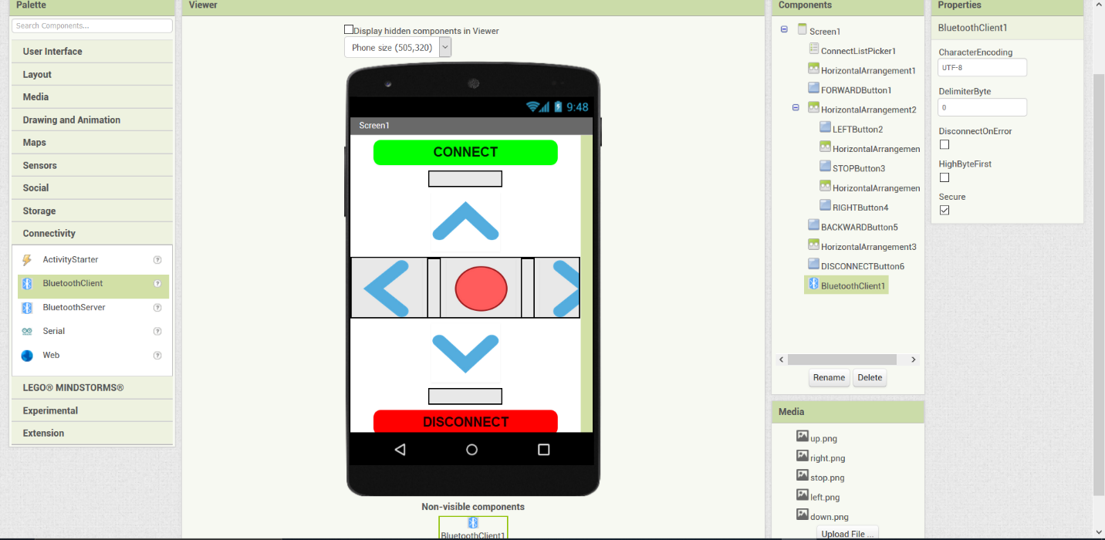

**Back-End For**

**Button Controlled Bot**

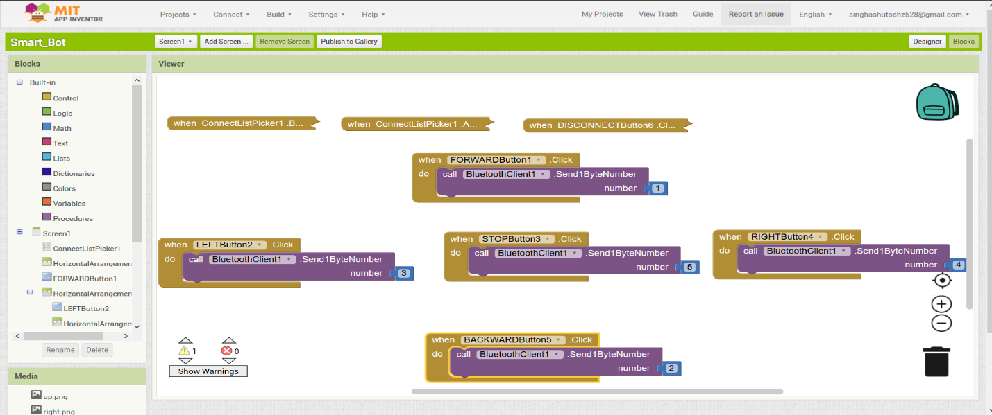

**Front-End For**

**Voice Controlled Bot**

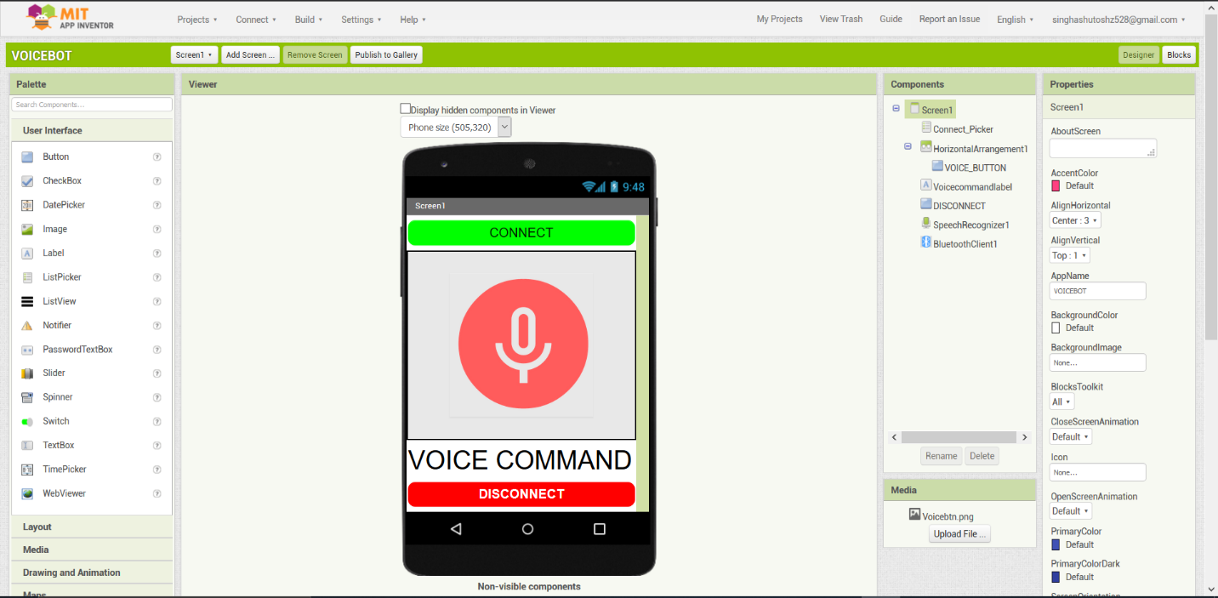

**Back-End For**

**Voice Controlled Bot**

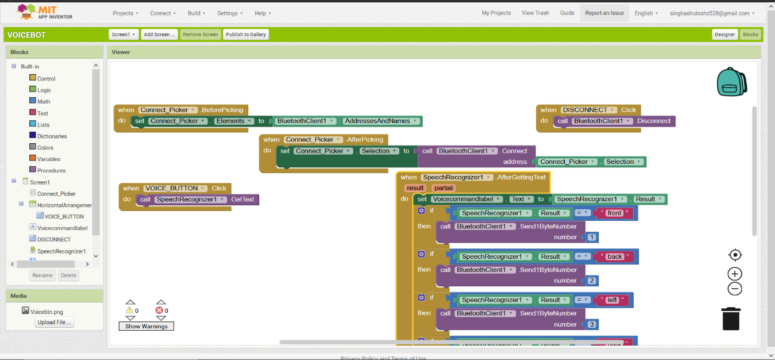

**Front-End For**

**Gesture Controlled Bot**

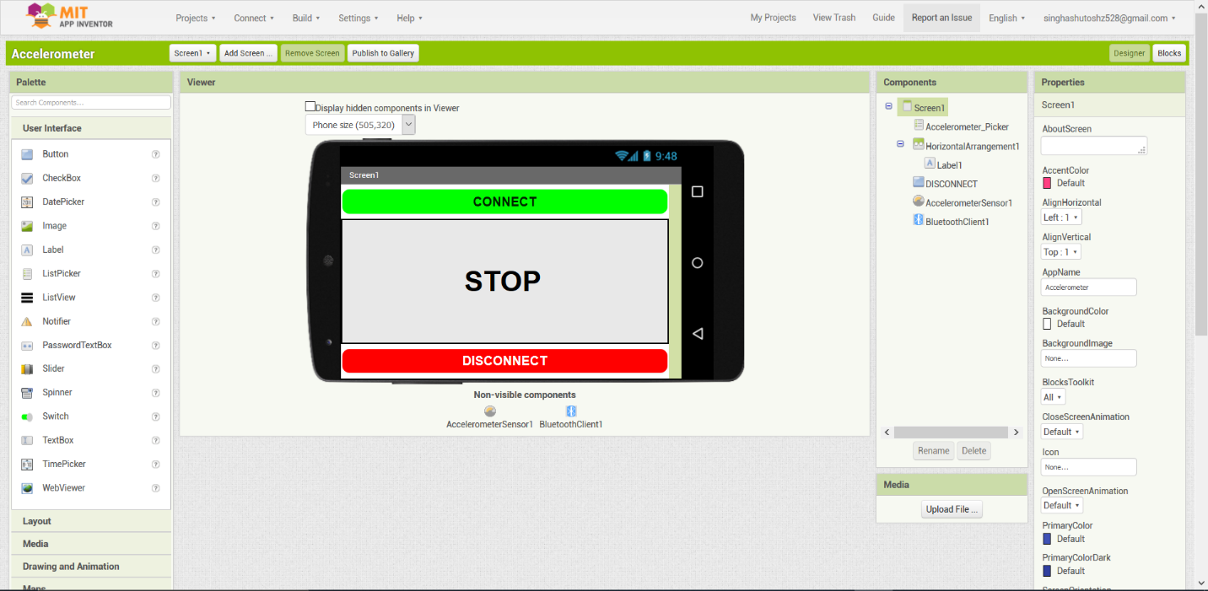

**Back-End For**

**Gesture Controlled Bot**

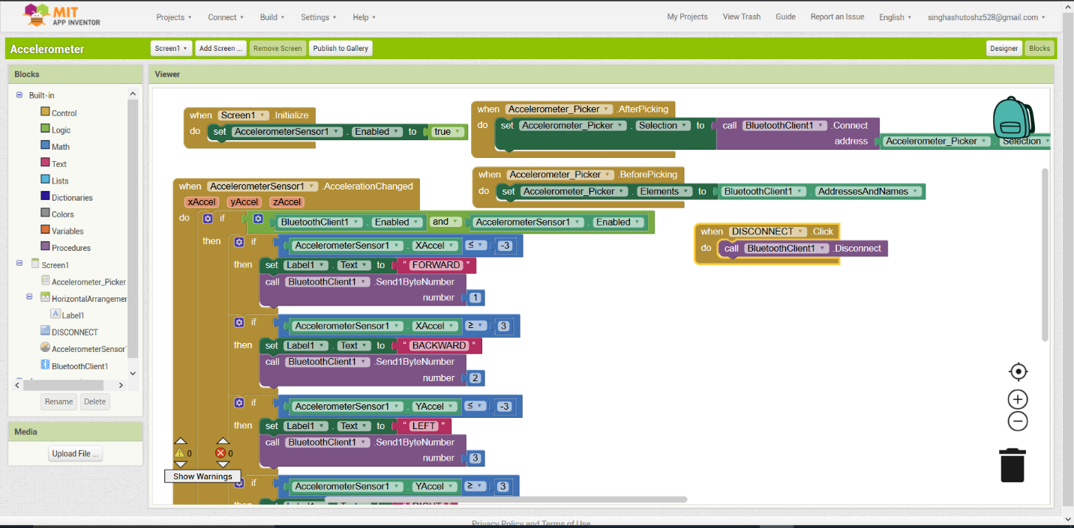

**RESULT**

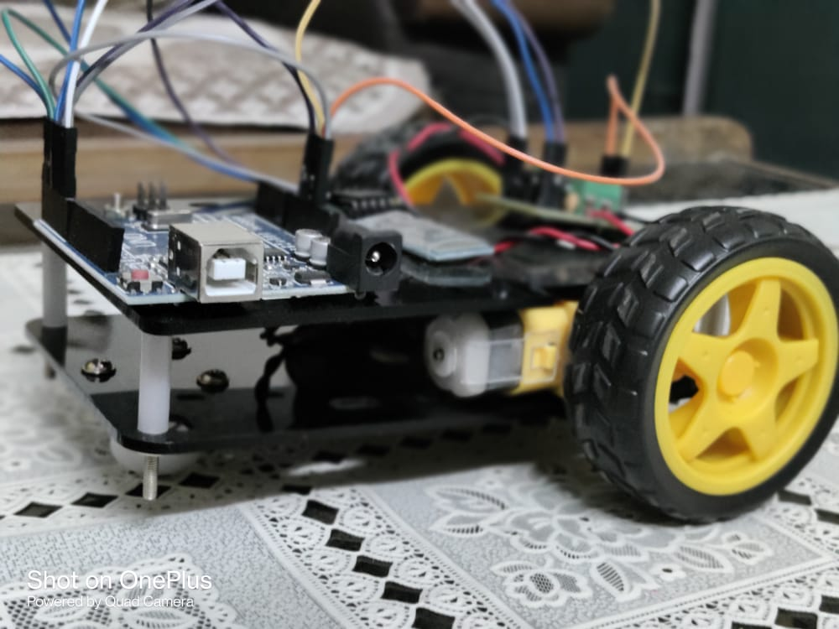

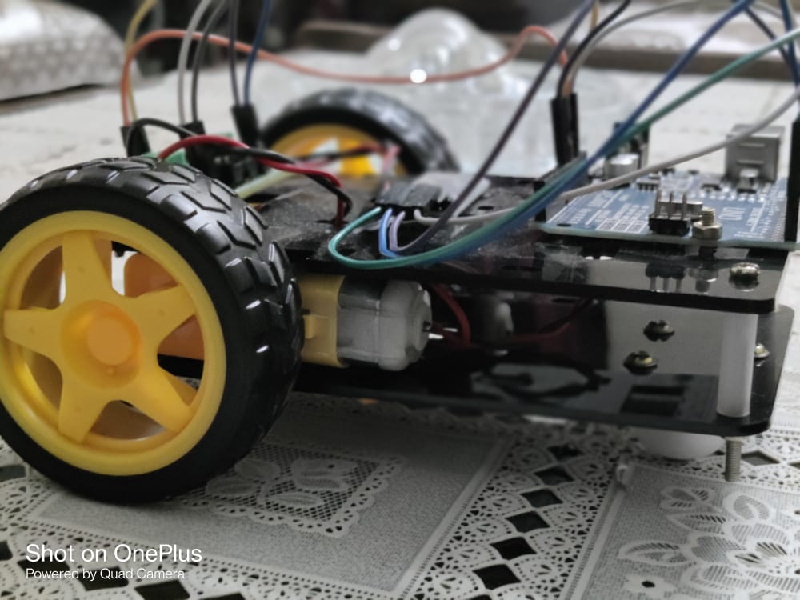

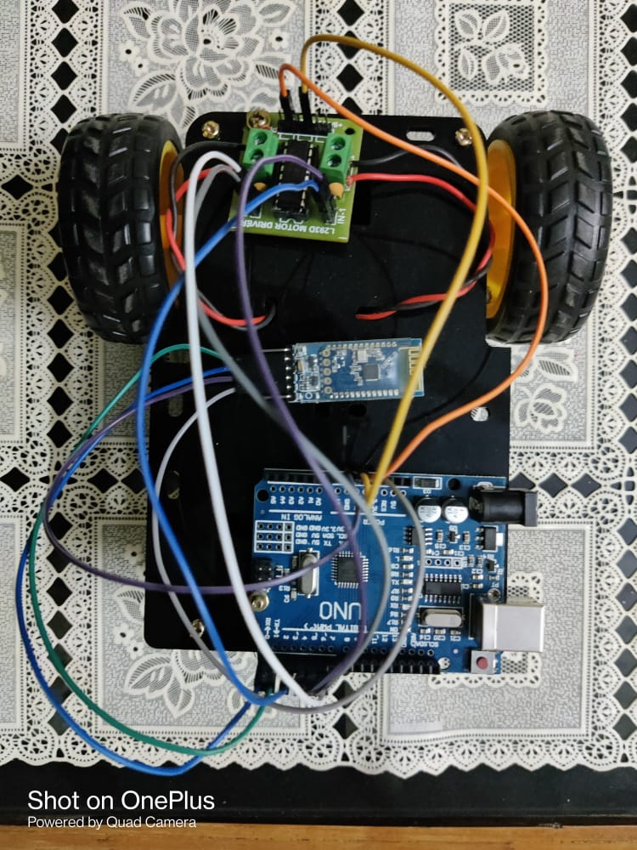

**REFERENCES**

1. "Arduino",en.wikipedia.org,2010.[Online].Available: <https://en.wikipedia.org/wiki/Arduino>.
2. “ArduinoCommunity”[Online].Available: <https://www.arduino.cc/>

**TEAM DETAILS**

1. Ashutosh Singh - 180103017